Videoconference Application

Project: Speak Apps
Author: UOC (Open University of Catalonia)

Head: Christine Appel
Chief Project: Marc Gener
Programmers: Juan Recio, Christian Moya, David Trelles, Marc Gener
Main menu

The videoconference application has three basic operations.

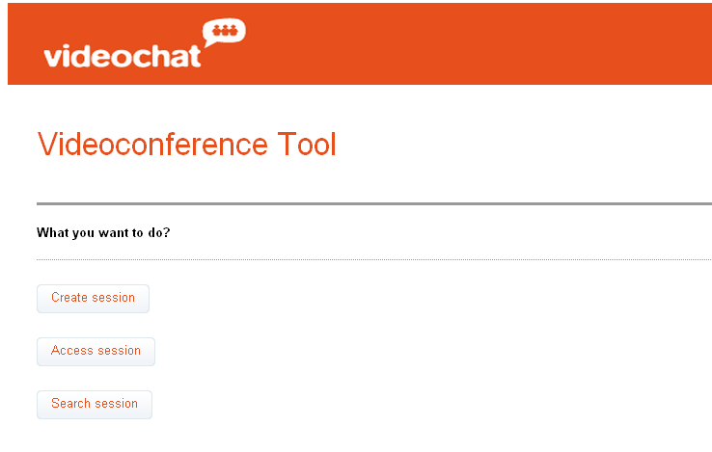

Create Videoconference Session

This operation creates a videoconference session; topic and description are data to identifier this.
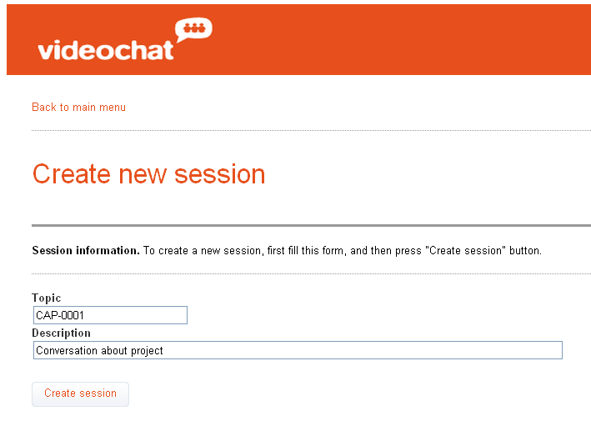

Press “Create session” button, appears in the screen the code to access this session:

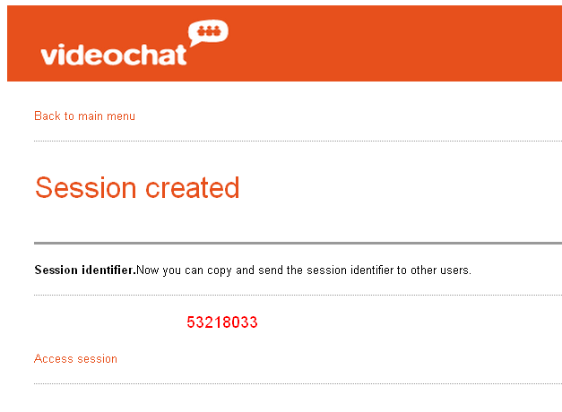
All the users that have this code, can access in this videoconference session. The maximum number supported is six persons.

Access Videoconference Session

There are two possibilities to access in the session with the code, one is in the same moment that this has generated. For this, press the “Access session” link. Other possibility is press button “Access session” in the main menu.

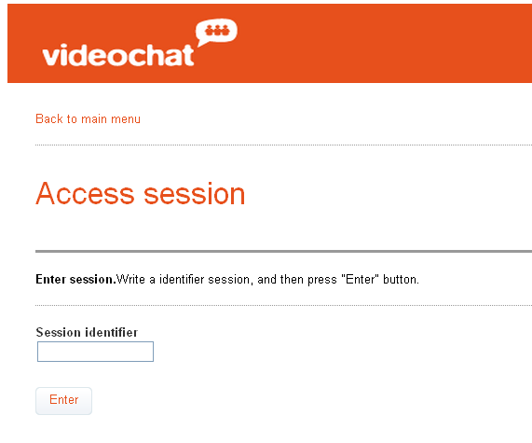
Put code in the box and you will go to the screen recording. Press the button “Allow” first, and the button “Activate Camera” after, and the session start.
Recorder Videoconference

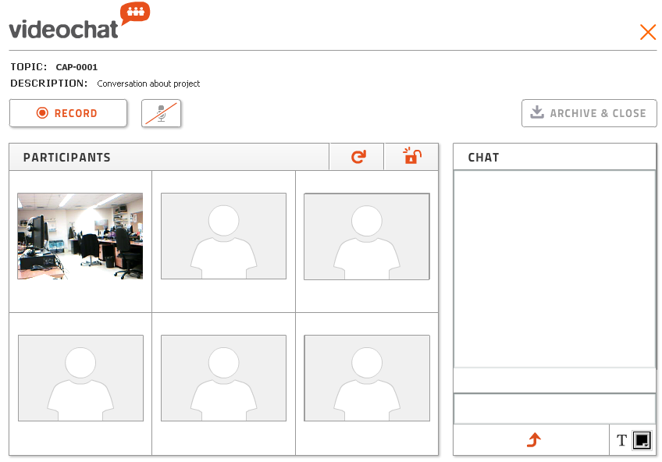

The elements in this screen are:

The “Record” button  → Record the videoconference session. If you not agree with this session, you can press this button other time.

The “Archive & close” button → If you accept the recorded videoconference session, press this button, and the recorded are archived in the system.

The refresh button → press this button if somebody participant, not appear in the screens.
The button → close the screen videoconference. Is important press this button always you want to go out. Internal operations are made.

The lock button → press this button you lock/unlock the access for this videoconference to other participants.

The microphone button  → to mitigate the background sound.

Chat → this display allows chat with other participants.

The button → cleans the display chat.

The button  → changes the text chat colour.
When you’ve already recorded a meeting, if you want back recording other time, the system notifies you with the next message:

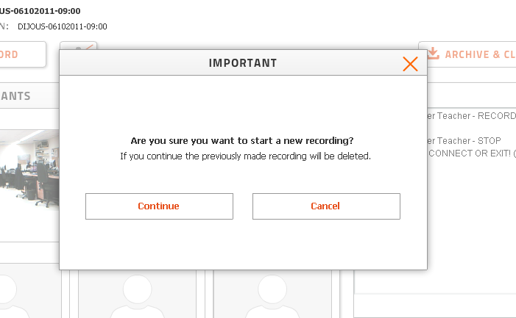

If you press button “Continue”, the previous recording will be deleted, and you will make a new recording.

When you are satisfied with the recording, you can give to validate and save this in the system, pressing “Archive & Close” button, and appears the next message:

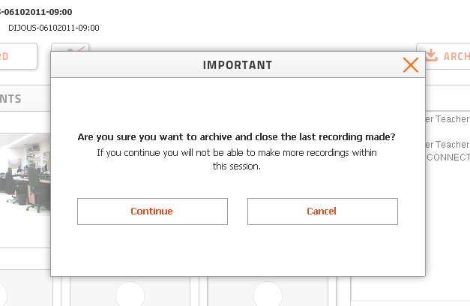

Search Videoconference

The search operation manages the videoconferences stored in the system. You can filter the search, by different parameters: topic, participants and date.

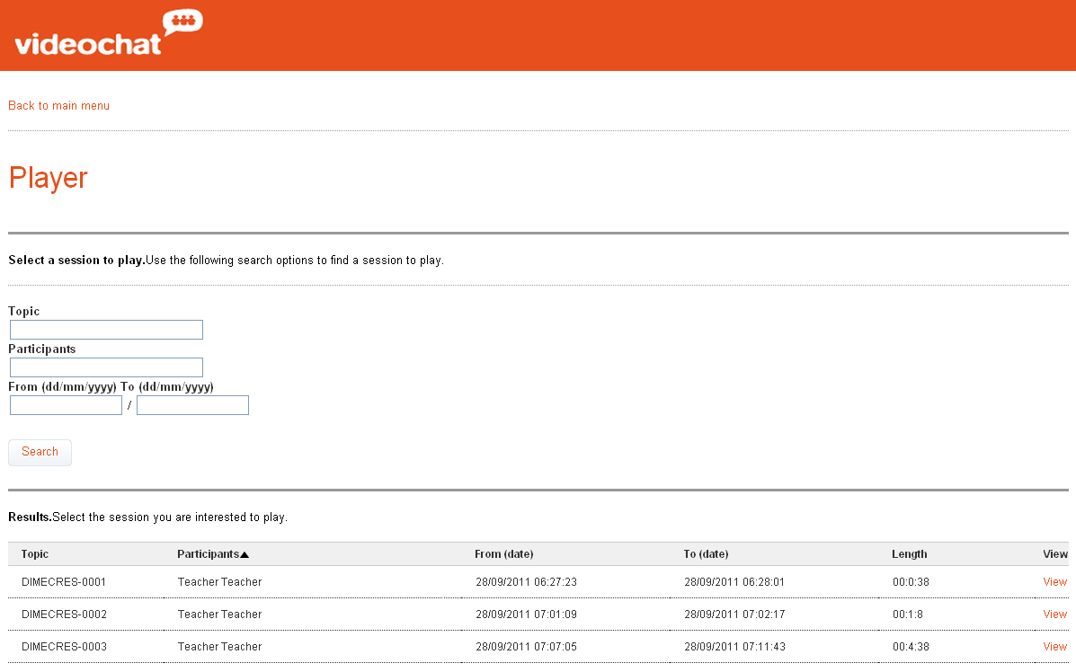

When you get the list, you can select the videoconference to see, press “View” link.

Player Videoconference

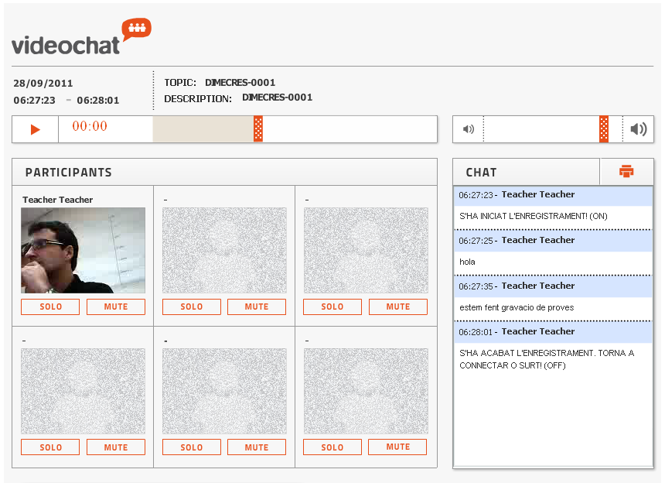

The elements in this screen are:

Play button → to play the videoconference.

Scrubber bar  → increase and decrease the volume.

Scrubber bar  → advance o decreases the sequence video.

“Solo” button → turn off all the audios except of this video.

“Mute” button → turn off the audio of this video.

Printer button → prints the chat of this videoconference.

Other considerations

- The maximum numbers of users that can to make a videoconference in a session are six persons.

- The users that haven’t permissions in a course cannot record and play videoconferences in that course.

- Sometimes the connection of some screen in the recorder is not works fine, and the user not appears, in this case press the button, until this appears in the camera.

- Is absolutely necessary press button, to left of recorder videoconference, this is because internal operations are made.

